Descriptive Statistics and Trends for Mortality Rates

# Descriptive Statistics for Mortality Rates

|  |  |  |  |  |  |
| --- | --- | --- | --- | --- | --- |
| Country | Mean Mortality Rate | Median Mortality Rate | Standard Deviation | Min Mortality Rate | Max Mortality Rate |
| albania | 7.466666666666668 | 11.2 | 6.384660436459319 | 0.0 | 14.3 |
| argentina | 7.883333333333333 | 12.45 | 6.694753335427842 | 0.0 | 14.1 |
| bangladesh | 8.725 | 13.05 | 7.488449438969326 | 0.0 | 15.9 |
| brazil | 11.316666666666668 | 16.55 | 9.725382026201109 | 0.0 | 23.6 |
| cameroon | 17.05 | 28.15 | 14.424891680702492 | 0.0 | 30.2 |
| china | 10.775 | 17.5 | 9.158067936706592 | 0.0 | 21.4 |
| colombia | 10.200000000000001 | 15.850000000000001 | 8.6880185696548 | 0.0 | 20.0 |
| costa rica | 9.083333333333334 | 14.3 | 7.7389526997449005 | 0.0 | 17.8 |
| cote d'ivoire | 13.883333333333333 | 23.1 | 11.747257363127595 | 0.0 | 25.4 |
| ecuador | 12.025 | 16.8 | 10.451963531636851 | 0.0 | 24.0 |
| egypt, arab rep. | 6.333333333333333 | 9.95 | 5.391248051755322 | 0.0 | 12.3 |
| gabon | 13.466666666666669 | 22.0 | 11.401559347543454 | 0.0 | 23.9 |
| georgia | 7.875 | 11.8 | 6.750570963506223 | 0.0 | 15.8 |
| ghana | 14.558333333333332 | 24.2 | 12.31330299129992 | 0.0 | 25.8 |
| honduras | 9.358333333333333 | 15.7 | 7.9122750977340415 | 0.0 | 16.4 |
| india | 9.183333333333334 | 15.25 | 7.772369151180496 | 0.0 | 16.9 |
| indonesia | 7.191666666666666 | 11.45 | 6.124331029227238 | 0.0 | 14.5 |
| iran, islamic rep. | 12.966666666666667 | 20.65 | 11.060841840575346 | 0.0 | 26.8 |
| iraq | 13.075000000000001 | 20.4 | 11.289901461040305 | 0.0 | 27.3 |
| jamaica | 7.7749999999999995 | 12.0 | 6.622829833235941 | 0.0 | 15.1 |
| japan | 3.016666666666667 | 3.6500000000000004 | 3.4277867819078565 | 0.0 | 12.5 |
| jordan | 12.608333333333334 | 17.3 | 10.876692077812793 | 0.0 | 24.1 |
| kazakhstan | 9.166666666666666 | 13.25 | 7.971755696763976 | 0.0 | 19.3 |
| kenya | 15.975 | 26.5 | 13.510312419284265 | 0.0 | 28.3 |
| lao pdr | 9.483333333333334 | 14.5 | 8.073292733176194 | 0.0 | 17.9 |
| malaysia | 13.725 | 22.6 | 11.64947244871343 | 0.0 | 26.8 |
| mexico | 7.8 | 12.9 | 6.600631282940544 | 0.0 | 14.2 |
| peru | 8.191666666666666 | 13.6 | 6.945437151268609 | 0.0 | 15.8 |
| philippines | 6.758333333333333 | 10.350000000000001 | 5.749559161844981 | 0.0 | 12.5 |
| russian federation | 9.874999999999998 | 12.45 | 9.249245464721254 | 0.0 | 27.9 |
| turkiye | 5.2 | 7.550000000000001 | 4.461501989240843 | 0.0 | 9.9 |
| turkmenistan | 8.766666666666667 | 13.8 | 7.458030720117892 | 0.0 | 16.4 |
| turks and caicos islands | 0.0 | 0.0 | 0.0 | 0.0 | 0.0 |
| tuvalu | 0.0 | 0.0 | 0.0 | 0.0 | 0.0 |
| uganda | 17.816666666666666 | 29.549999999999997 | 15.09623757394169 | 0.0 | 33.9 |
| ukraine | 7.0249999999999995 | 10.1 | 6.068652376489088 | 0.0 | 13.7 |
| united arab emirates | 8.608333333333334 | 10.100000000000001 | 7.721232450558366 | 0.0 | 18.1 |
| united kingdom | 2.1 | 2.95 | 2.053046516764781 | 0.0 | 6.9 |
| united states | 7.508333333333333 | 11.7 | 6.418652290179163 | 0.0 | 15.7 |
| uruguay | 8.875 | 13.75 | 7.549185938452791 | 0.0 | 16.8 |
| uzbekistan | 6.425 | 9.95 | 5.4601778054076835 | 0.0 | 11.9 |
| vanuatu | 8.758333333333333 | 14.45 | 7.4098423659946295 | 0.0 | 15.5 |
| venezuela, rb | 20.61666666666667 | 30.95 | 17.642034715102703 | 0.0 | 39.0 |
| viet nam | 15.708333333333334 | 24.4 | 13.38459676477239 | 0.0 | 30.6 |
| virgin islands (u.s.) | 0.0 | 0.0 | 0.0 | 0.0 | 0.0 |
| west bank and gaza | 0.44166666666666665 | 0.0 | 1.4648426157403016 | 0.0 | 5.3 |
| yemen, rep. | 15.399999999999999 | 23.1 | 13.142298124757327 | 0.0 | 29.4 |
| zambia | 12.641666666666666 | 20.5 | 10.833932675728708 | 0.0 | 27.4 |
| zimbabwe | 22.308333333333334 | 33.6 | 19.07544050751006 | 0.0 | 41.2 |
| africa eastern and southern | 17.029744958956403 | 28.411961456499434 | 14.408755860514376 | 0.0 | 31.21171011881088 |
| africa western and central | 14.58651014380609 | 24.3964363841949 | 12.36788579444977 | 0.0 | 28.1901840782264 |
| arab world | 11.644849539785843 | 19.65705830552318 | 9.843084764795282 | 0.0 | 20.19808073920409 |
| caribbean small states | 8.537760274165137 | 14.072811204597695 | 7.24216005515367 | 0.0 | 16.56420313174923 |
| central europe and the baltics | 5.738323577025761 | 8.581077212938492 | 5.218503909440614 | 0.0 | 15.99063982971203 |
| early-demographic dividend | 9.554469017063866 | 16.177356637713082 | 8.076683035122032 | 0.0 | 16.84754551050895 |
| east asia & pacific (excluding high income) | 10.742178829272566 | 17.7236219624504 | 9.111431693678025 | 0.0 | 20.81189419886947 |
| east asia & pacific (ida & ibrd countries) | 10.703758432943834 | 17.64402629791669 | 9.08023633271862 | 0.0 | 20.78729531156606 |
| euro area | 3.669332266687846 | 4.95565330159863 | 3.77224057619437 | 0.0 | 13.1659929378945 |
| europe & central asia | 5.488320177107624 | 7.608019421783419 | 4.993036045345993 | 0.0 | 15.04903649791817 |
| europe & central asia (excluding high income) | 7.830976181976754 | 10.783152618746715 | 6.898431063222207 | 0.0 | 18.35907176916058 |
| europe & central asia (ida & ibrd countries) | 7.60347875342374 | 10.61375174061095 | 6.694206010454129 | 0.0 | 18.03971623849077 |
| european union | 4.038772612670976 | 5.653862161363103 | 3.9773109125759536 | 0.0 | 13.45938669563903 |
| fragile and conflict affected situations | 14.602904594368548 | 24.646550883395946 | 12.344562429431969 | 0.0 | 25.57200465918897 |
| heavily indebted poor countries (hipc) | 16.073633838546357 | 27.067231621539413 | 13.58813867781728 | 0.0 | 28.16358827157177 |
| high income | 5.357123371328434 | 8.229609187478943 | 4.776156303688117 | 0.0 | 14.05292661902378 |
| ibrd only | 10.081632117597609 | 16.549537219746647 | 8.552215273103371 | 0.0 | 19.45224713379908 |
| late-demographic dividend | 11.018401668281067 | 17.64740902140283 | 9.372236064577244 | 0.0 | 21.91962095318036 |
| latin america & caribbean | 10.47510628771119 | 17.363751437249796 | 8.862897394196569 | 0.0 | 19.00125070413312 |
| latin america & caribbean (excluding high income) | 10.04997192447762 | 16.445724285624983 | 8.508391958143836 | 0.0 | 18.43361681155497 |
| latin america & the caribbean (ida & ibrd countries) | 10.568982492386228 | 17.52774797456449 | 8.943206195635716 | 0.0 | 19.21196787697923 |
| least developed countries: un classification | 14.456471611961296 | 23.990492818786393 | 12.226852590483224 | 0.0 | 25.6267757099447 |
| low & middle income | 10.874215272975102 | 18.18630221226485 | 9.203741276312233 | 0.0 | 20.13195776902686 |
| low income | 16.320636437993205 | 27.574588143686714 | 13.79615589153627 | 0.0 | 28.65550040510488 |
| lower middle income | 10.210552191822513 | 17.251991251476802 | 8.632201091781846 | 0.0 | 18.14035944721485 |
| middle income | 10.306154822980766 | 17.06105503190594 | 8.732013678324062 | 0.0 | 19.49531544840296 |
| south asia | 8.972202982409682 | 15.085418593703665 | 7.586245148980242 | 0.0 | 15.93745614784808 |
| south asia (ida & ibrd) | 8.972202982409682 | 15.085418593703665 | 7.586245148980242 | 0.0 | 15.93745614784808 |
| upper middle income | 10.39280933426016 | 16.64301913764477 | 8.843372216385303 | 0.0 | 20.78703829487171 |

# Mortality Rate Trends Over Time by Country

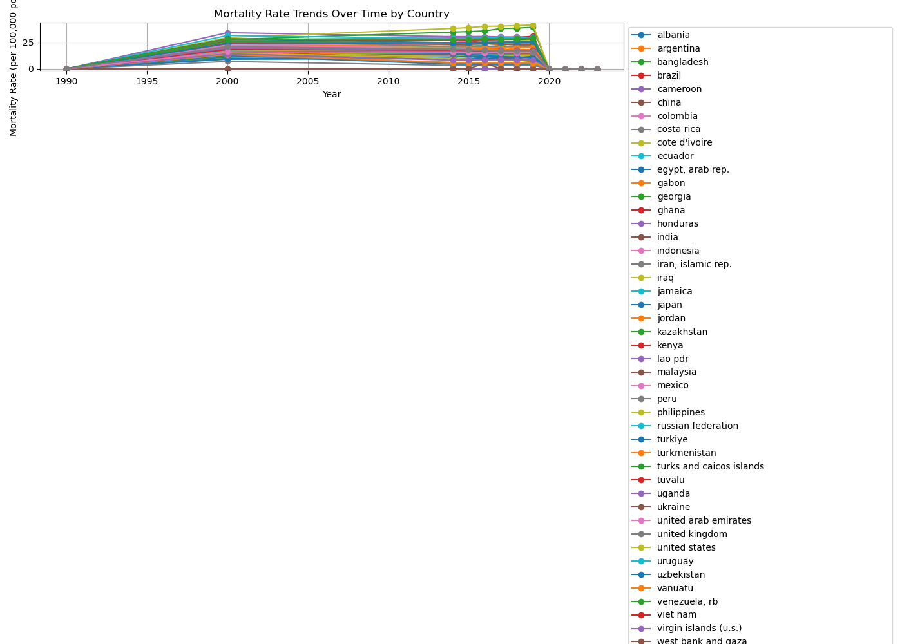

# Countries with Increasing Mortality Rates

bangladesh, ecuador, venezuela, rb, west bank and gaza, yemen, rep., zimbabwe

# Countries with Decreasing Mortality Rates

albania, argentina, brazil, cameroon, china, colombia, costa rica, cote d'ivoire, egypt, arab rep., gabon, georgia, ghana, honduras, india, indonesia, iran, islamic rep., iraq, jamaica, japan, jordan, kazakhstan, kenya, lao pdr, malaysia, mexico, peru, philippines, russian federation, turkiye, turkmenistan, uganda, ukraine, united arab emirates, united kingdom, united states, uruguay, uzbekistan, vanuatu, viet nam, zambia, africa eastern and southern, africa western and central, arab world, caribbean small states, central europe and the baltics, early-demographic dividend, east asia & pacific (excluding high income), east asia & pacific (ida & ibrd countries), euro area, europe & central asia, europe & central asia (excluding high income), europe & central asia (ida & ibrd countries), european union, fragile and conflict affected situations, heavily indebted poor countries (hipc), high income, ibrd only, late-demographic dividend, latin america & caribbean, latin america & caribbean (excluding high income), latin america & the caribbean (ida & ibrd countries), least developed countries: un classification, low & middle income, low income, lower middle income, middle income, south asia, south asia (ida & ibrd), upper middle income